Supplementary Data

Supplementary Figure 1: a) for any modality-specific or multimodal clock, biological age is estimated using the features included in modalities involved in that clock in a regression problem predicting biological age, and performance is assessed via correlation coefficient of biological age vs. chronological age. b) model architecture for early fusion and late fusion clock

a)
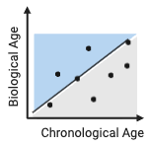
b)
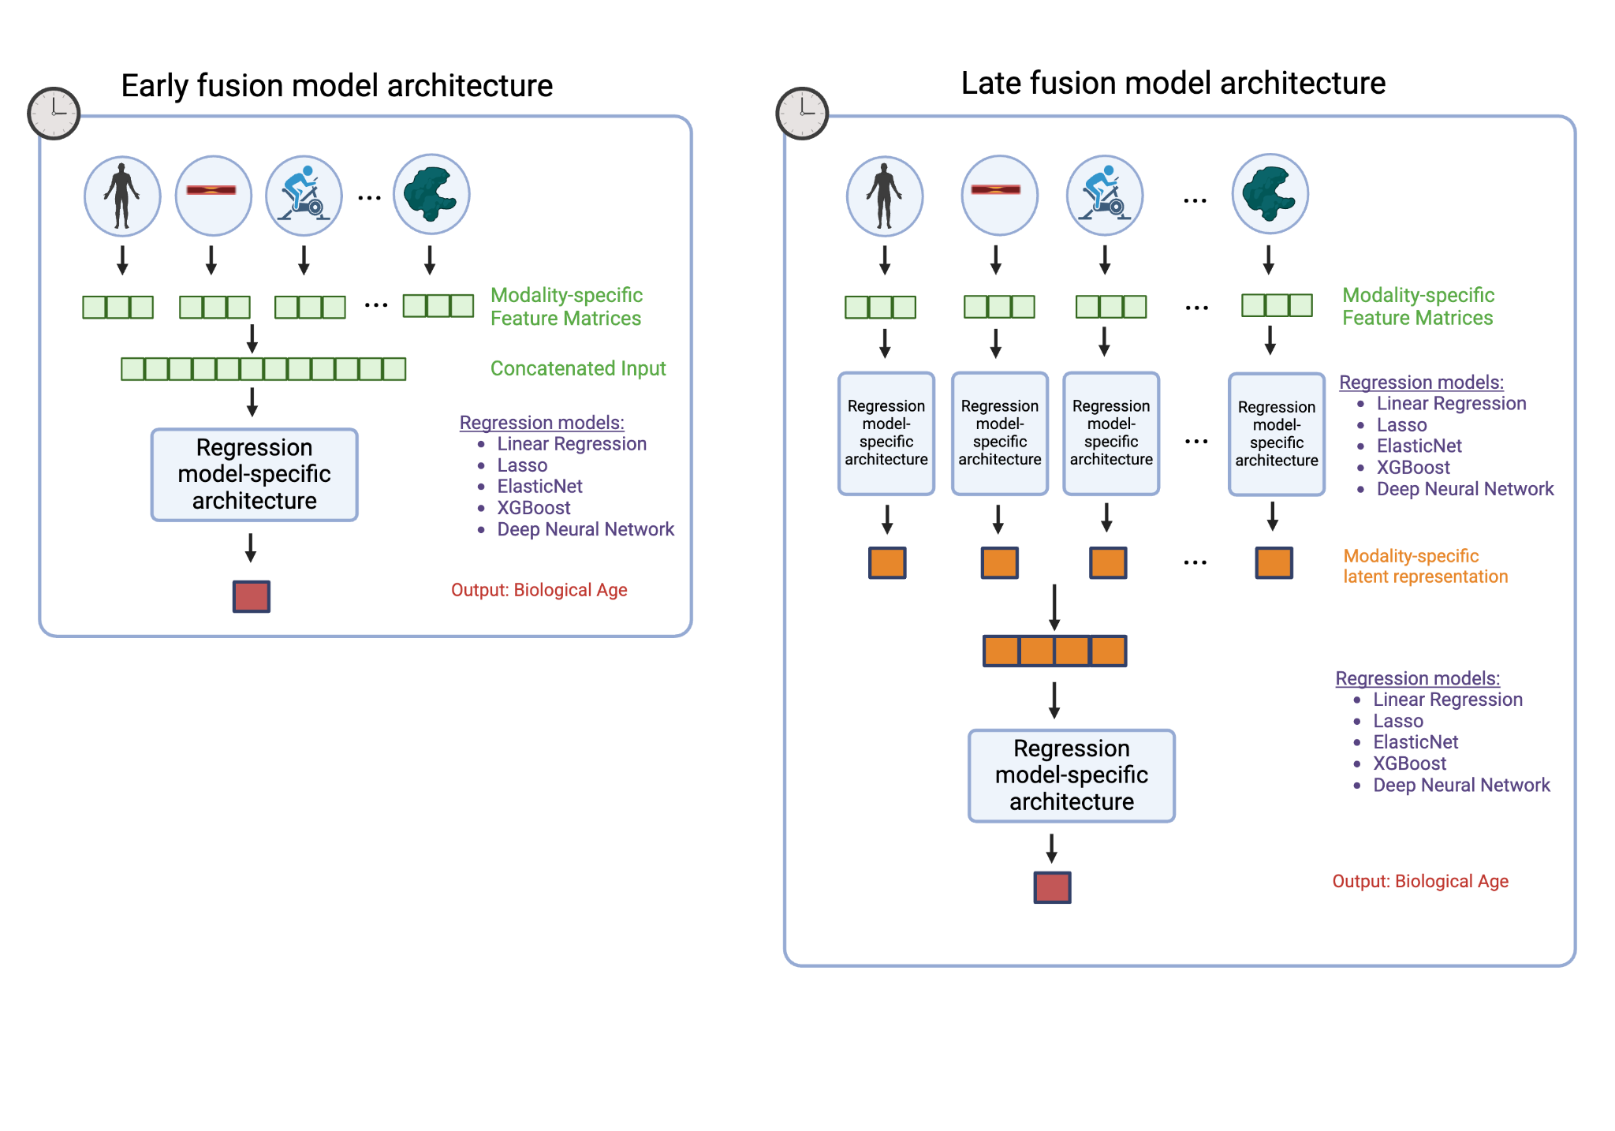

Supplementary Figure 2: a) relationship between feature sparsity and performance. b) relationship between clock training dataset size and performance
a)
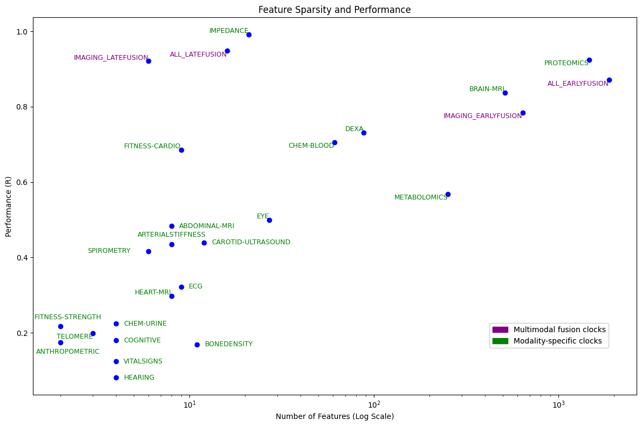
b)
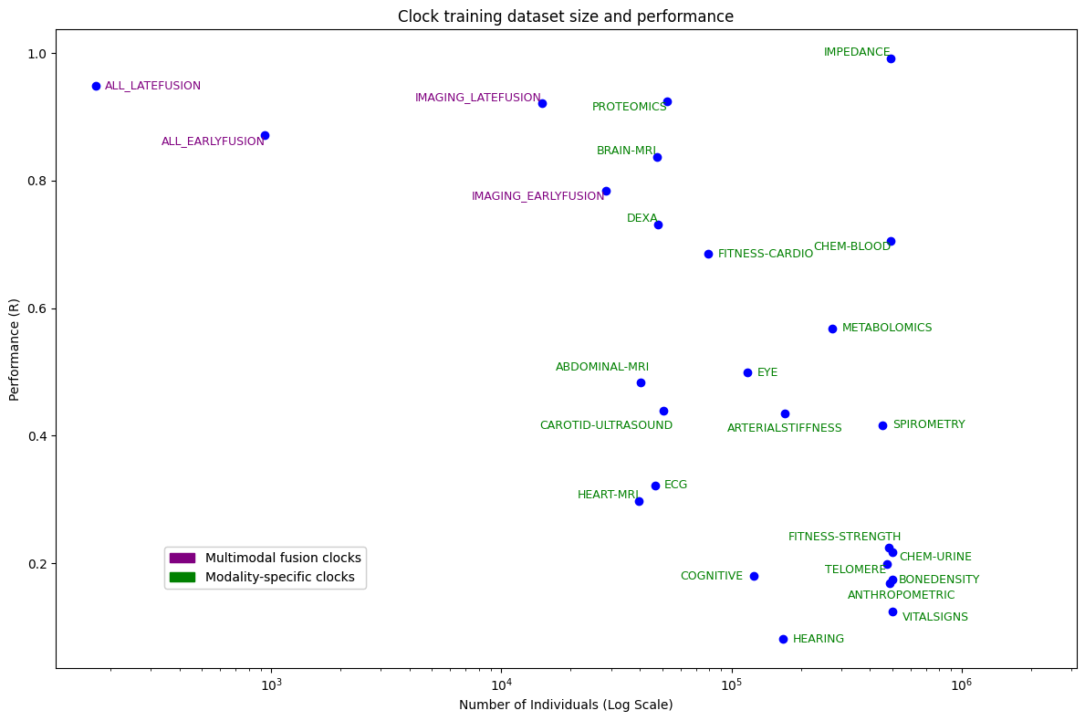

Supplementary Figure 3: additive performance of biological age acceleration in disease prediction compared to using sex and chronological age alone

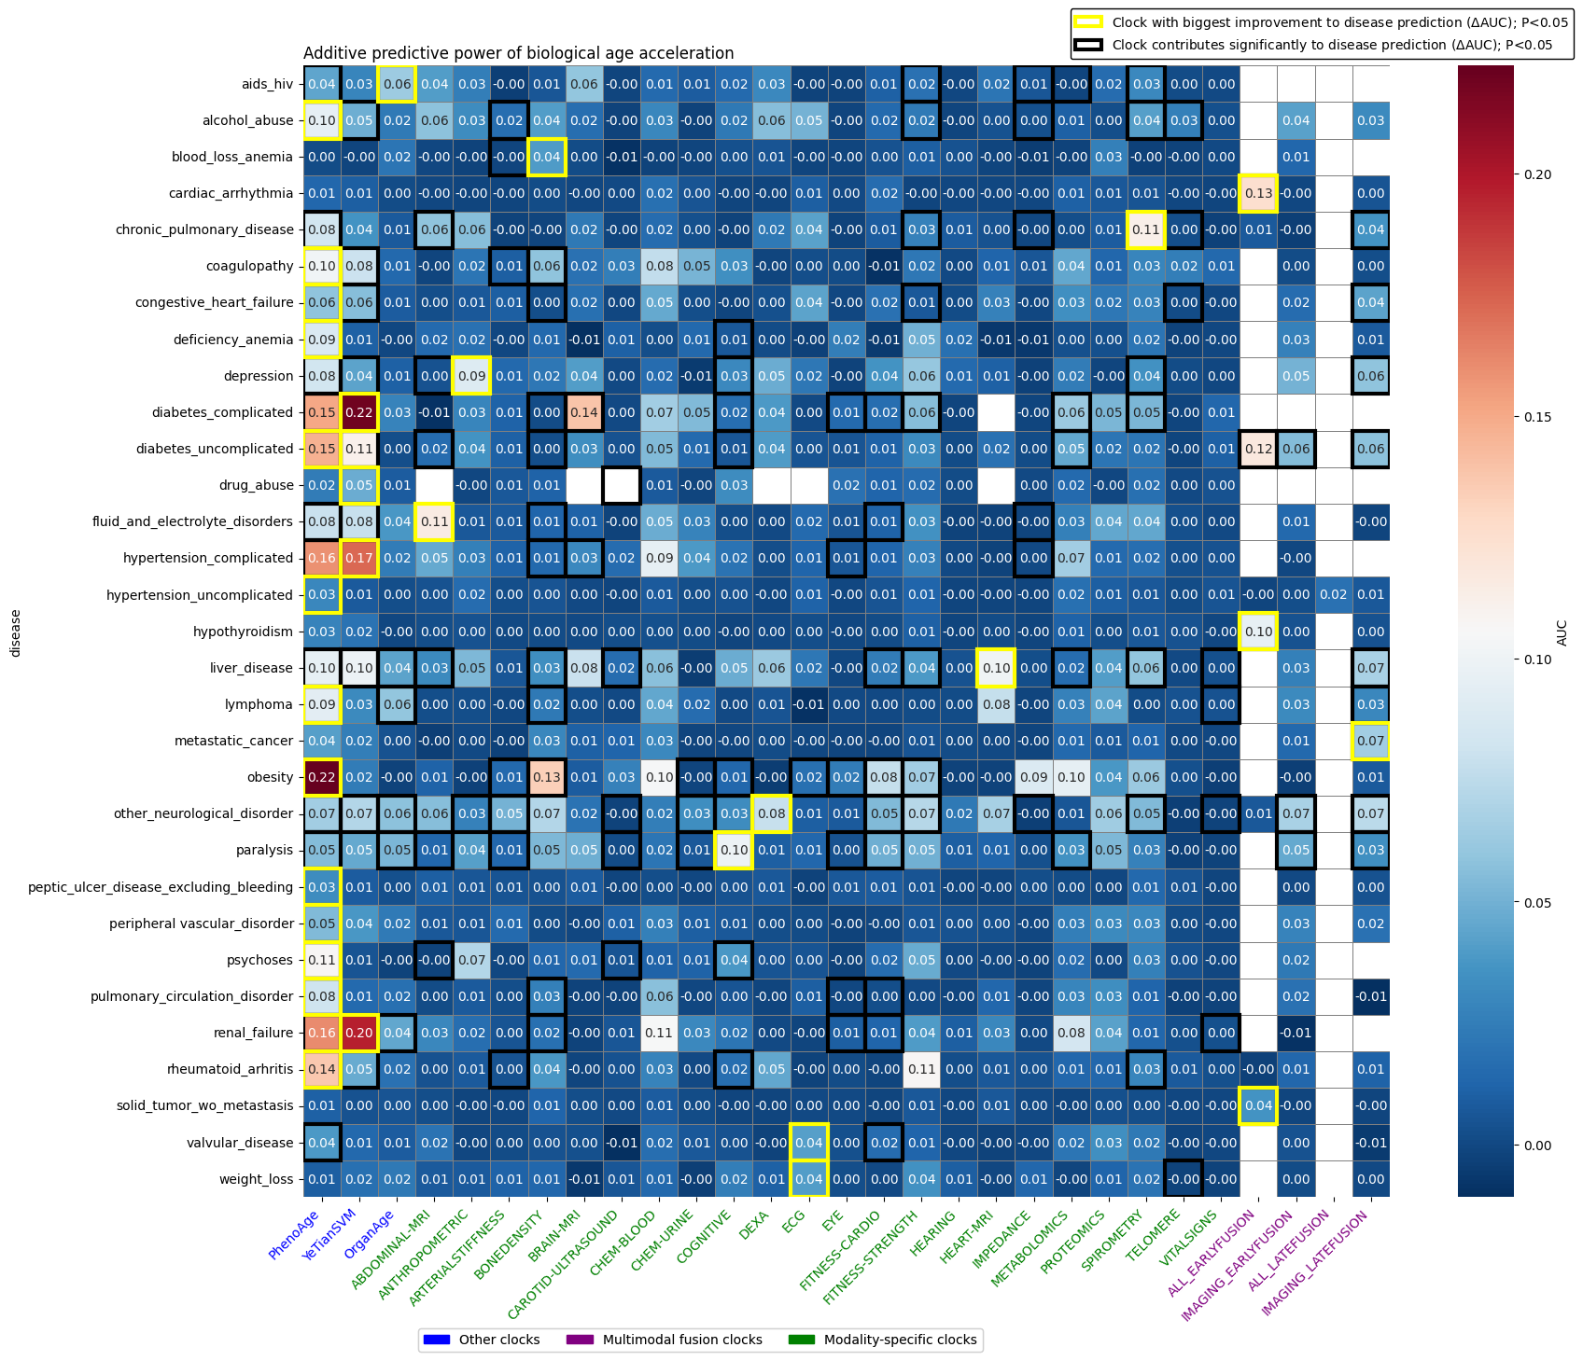

Supplementary Figure 4: a) disease associations for each clock, as well as baselines PhenoAge and Tian et al. biological age. yellow bolded box = best clock for performance increase in prediction of incident disease. Confidence intervals for AUC scores from bootstraps are reported in the supplementary table 6; b) correlation of each clock against others, based on strength of mortality associations across comorbidities.
4a)
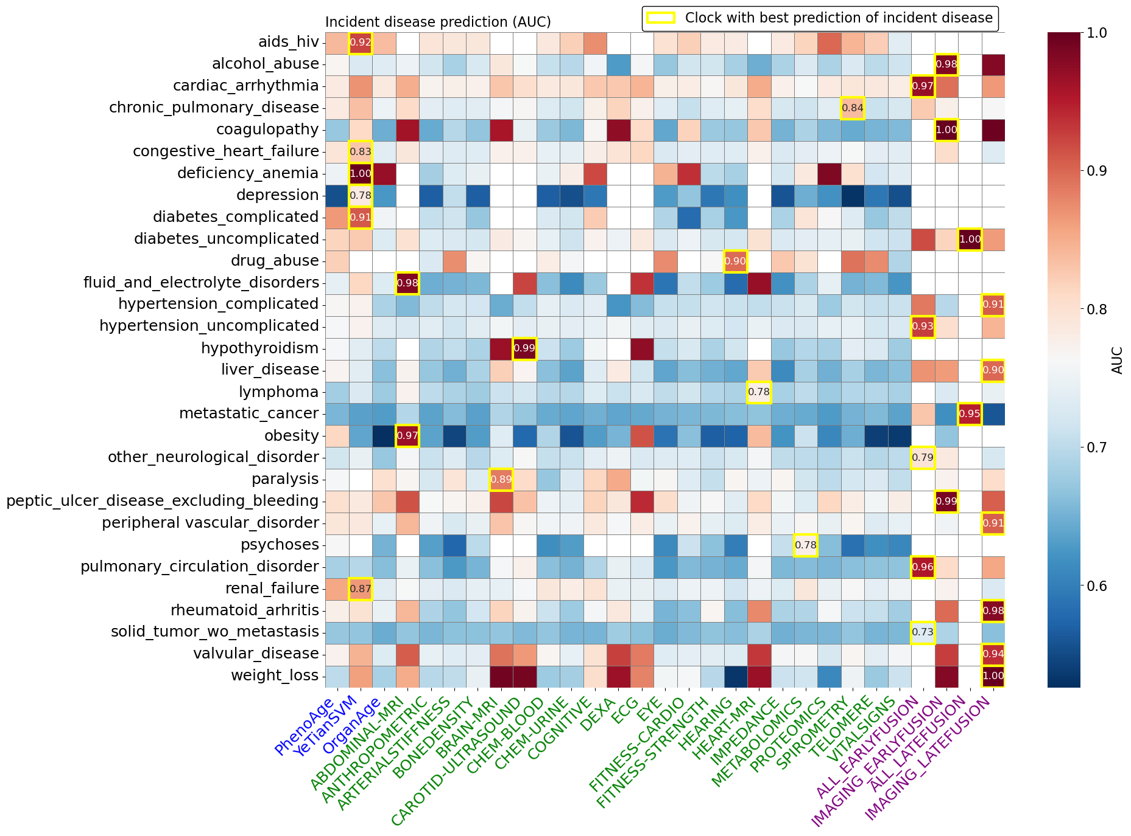
4b)
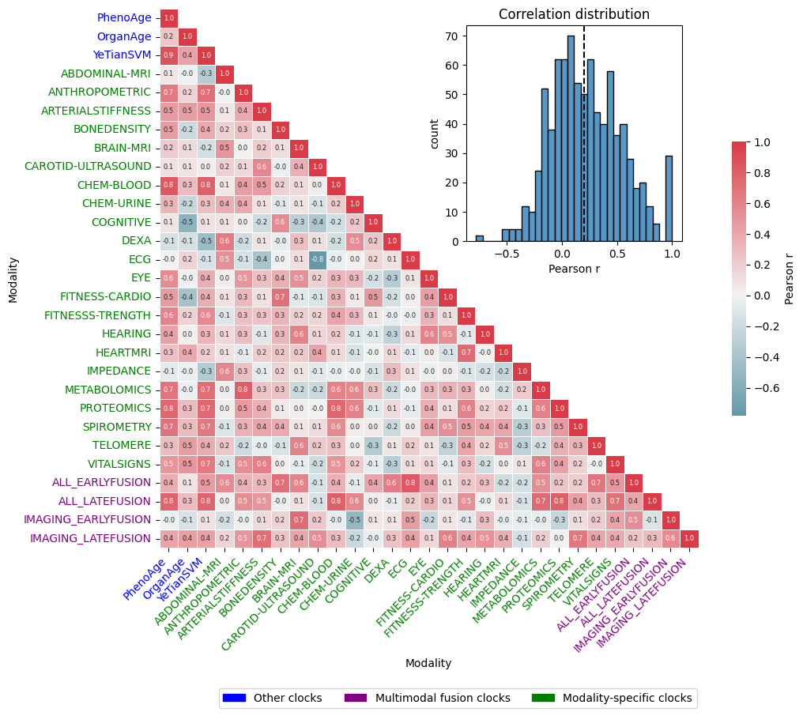

Supplementary Figure 5: a) Pearson correlation relationships between modality-specific and multimodal clocks (DNN) in NHANES data; b) mortality associations in NHANES data

5a)
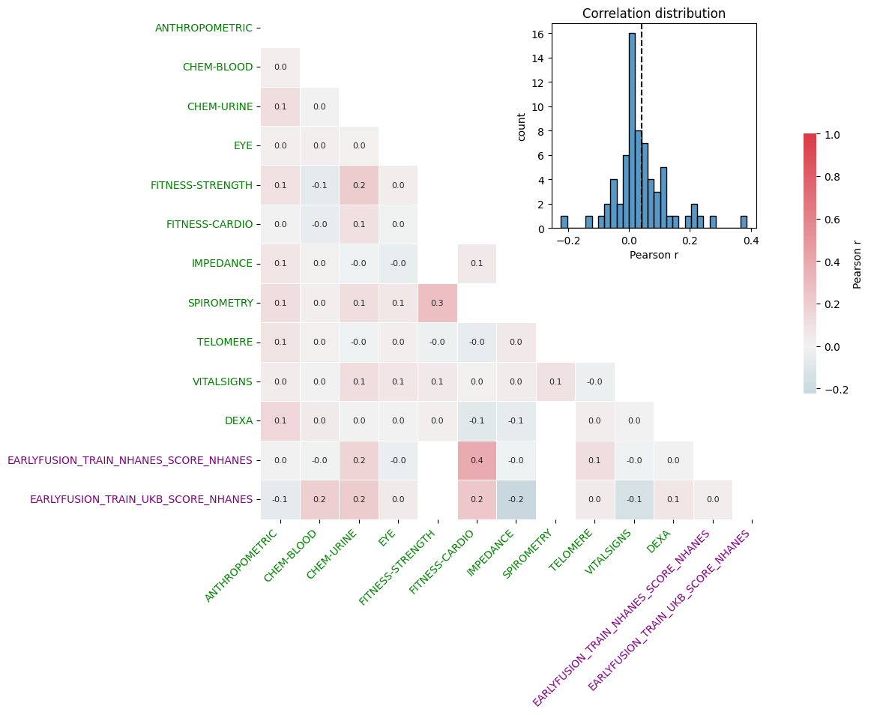
5b)
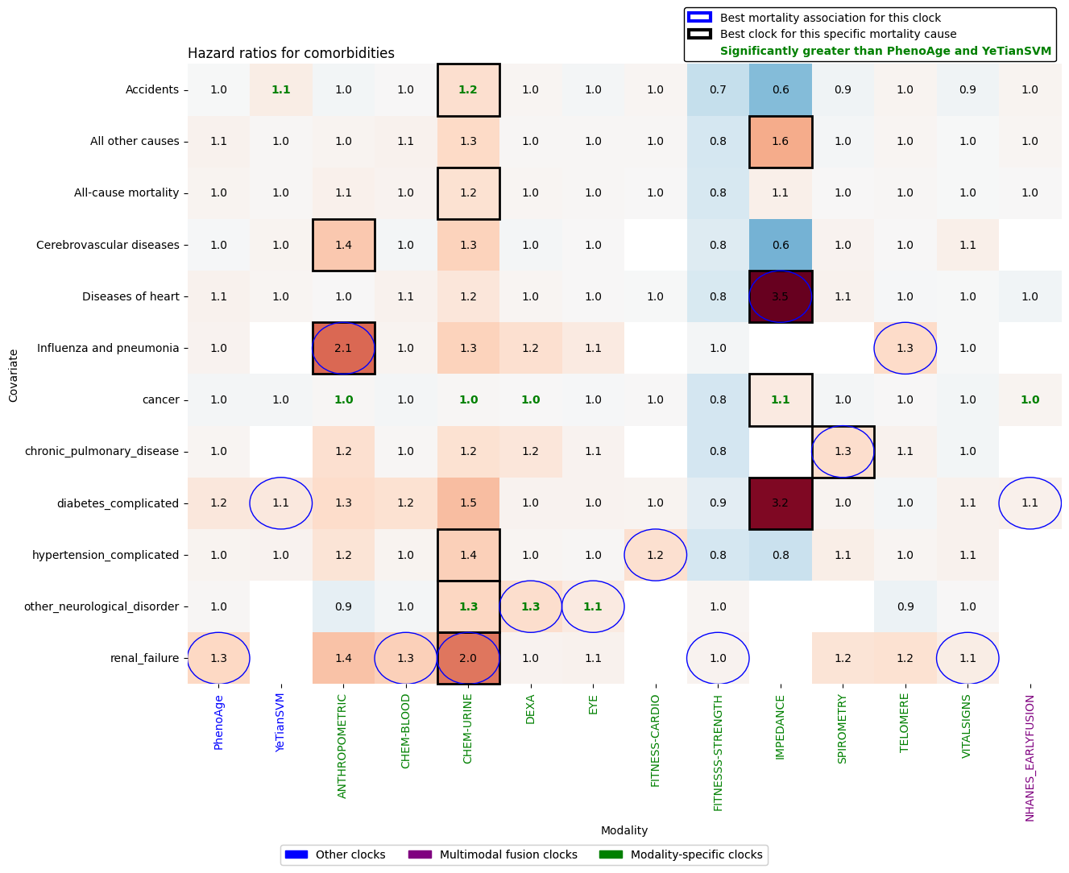

Supplementary Figure 6: a) blood chemistry-based biological age using the FusionAge-DNN-CHEM-BLOOD clock; (b) proteomics-based biological age using the FusionAge-DNN-PROTEOMICS clock;
a)
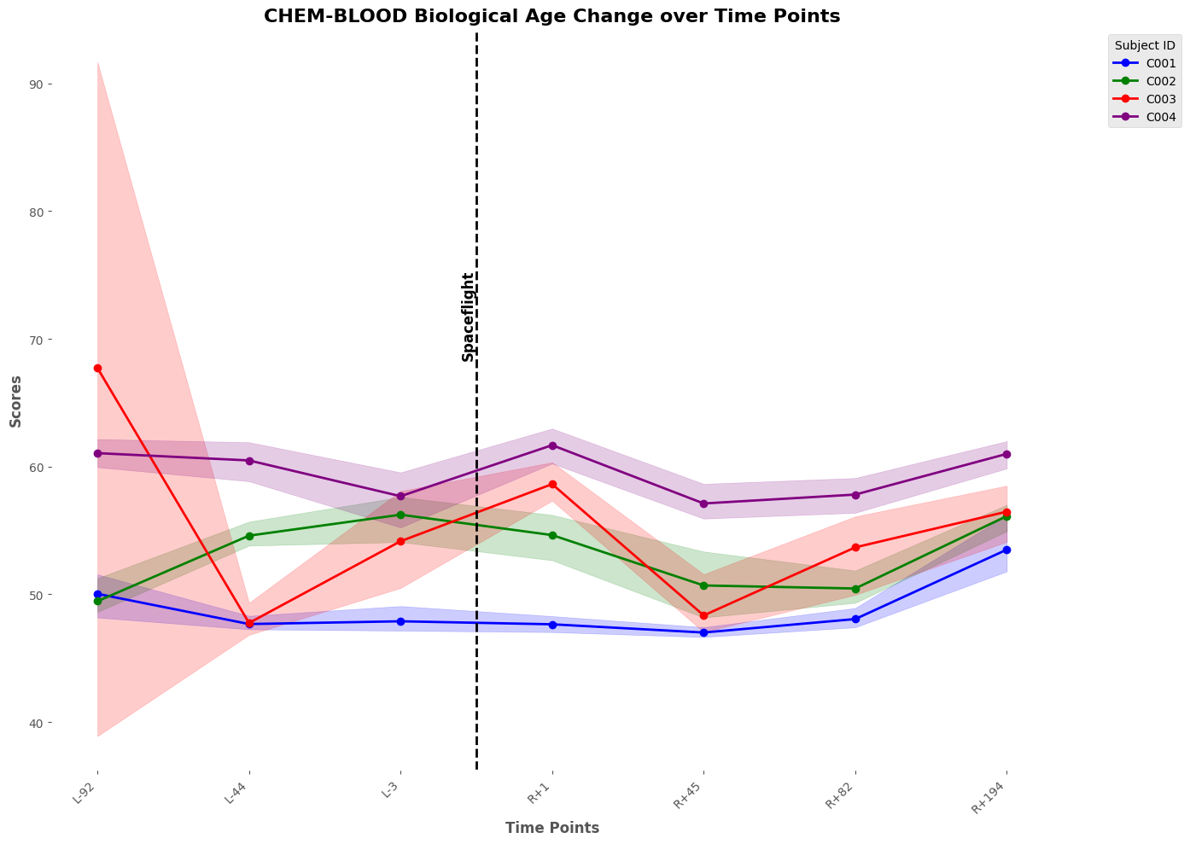
b)
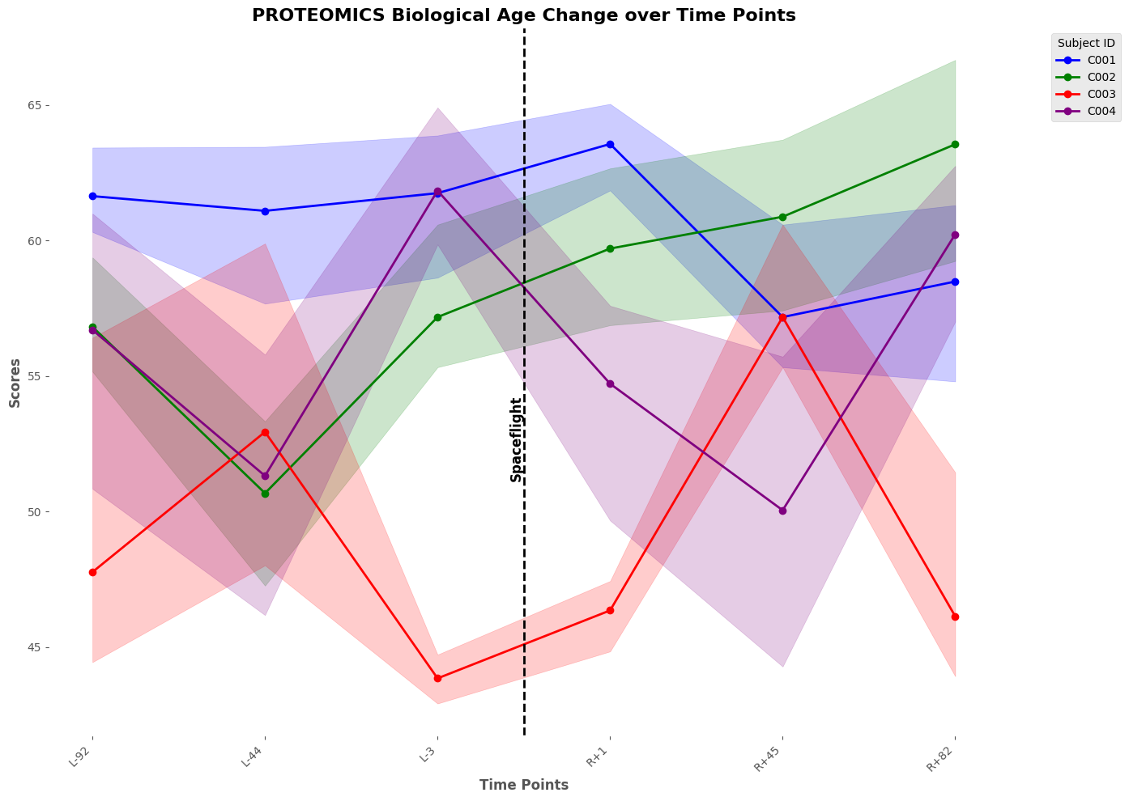

Supplementary Figure 7: distributions of biological age acceleration Z scores for FusionAge-derived aging clocks, in the UK Biobank cohort; data cohorts used for select clocks do not have individuals with that disease and those individuals are not plotted

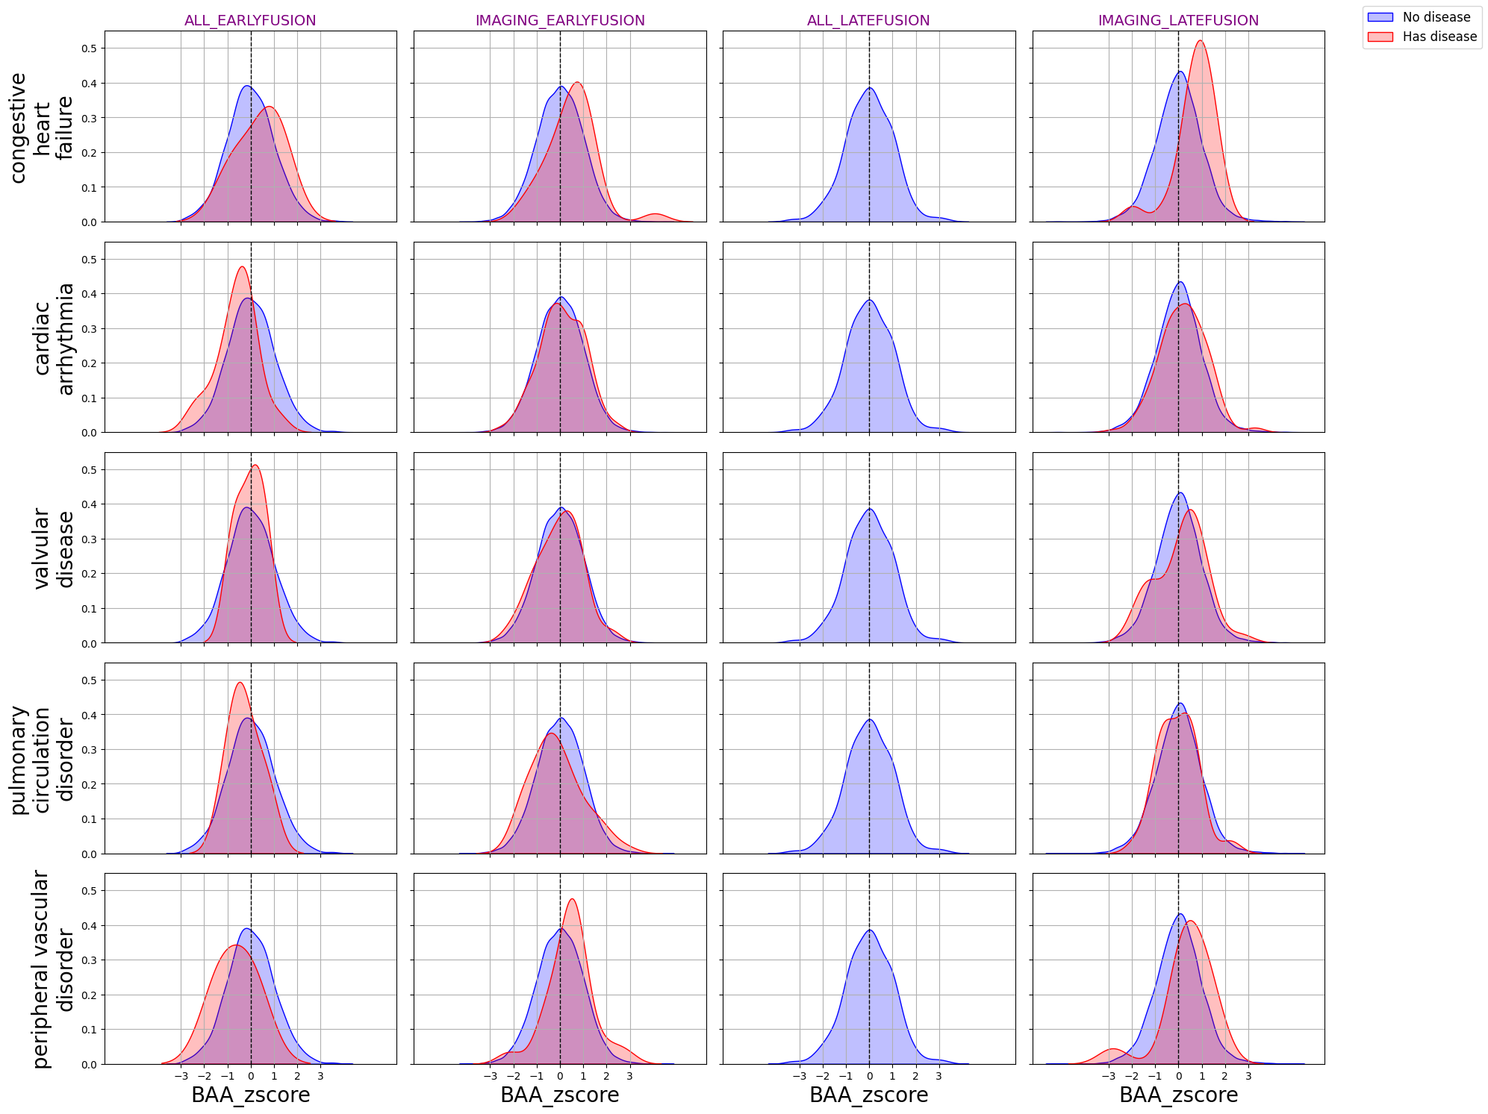

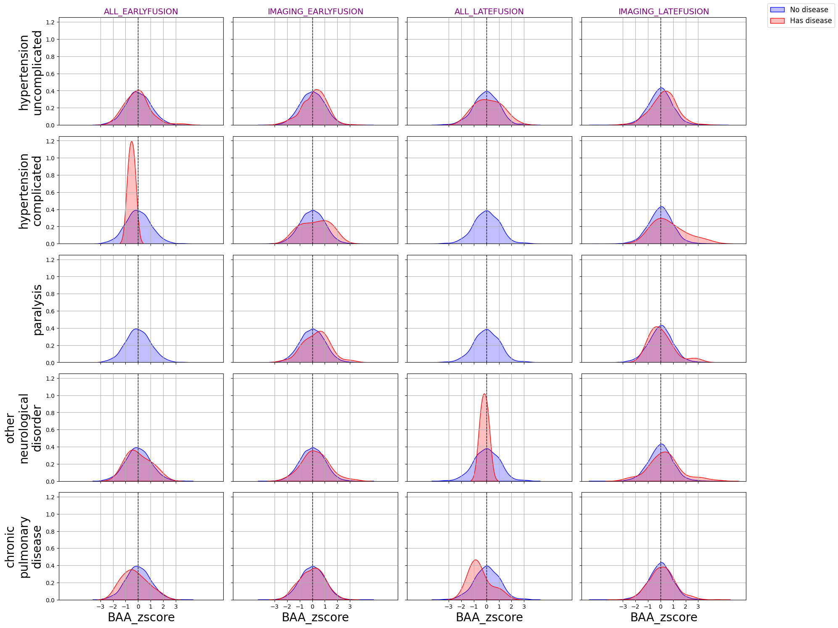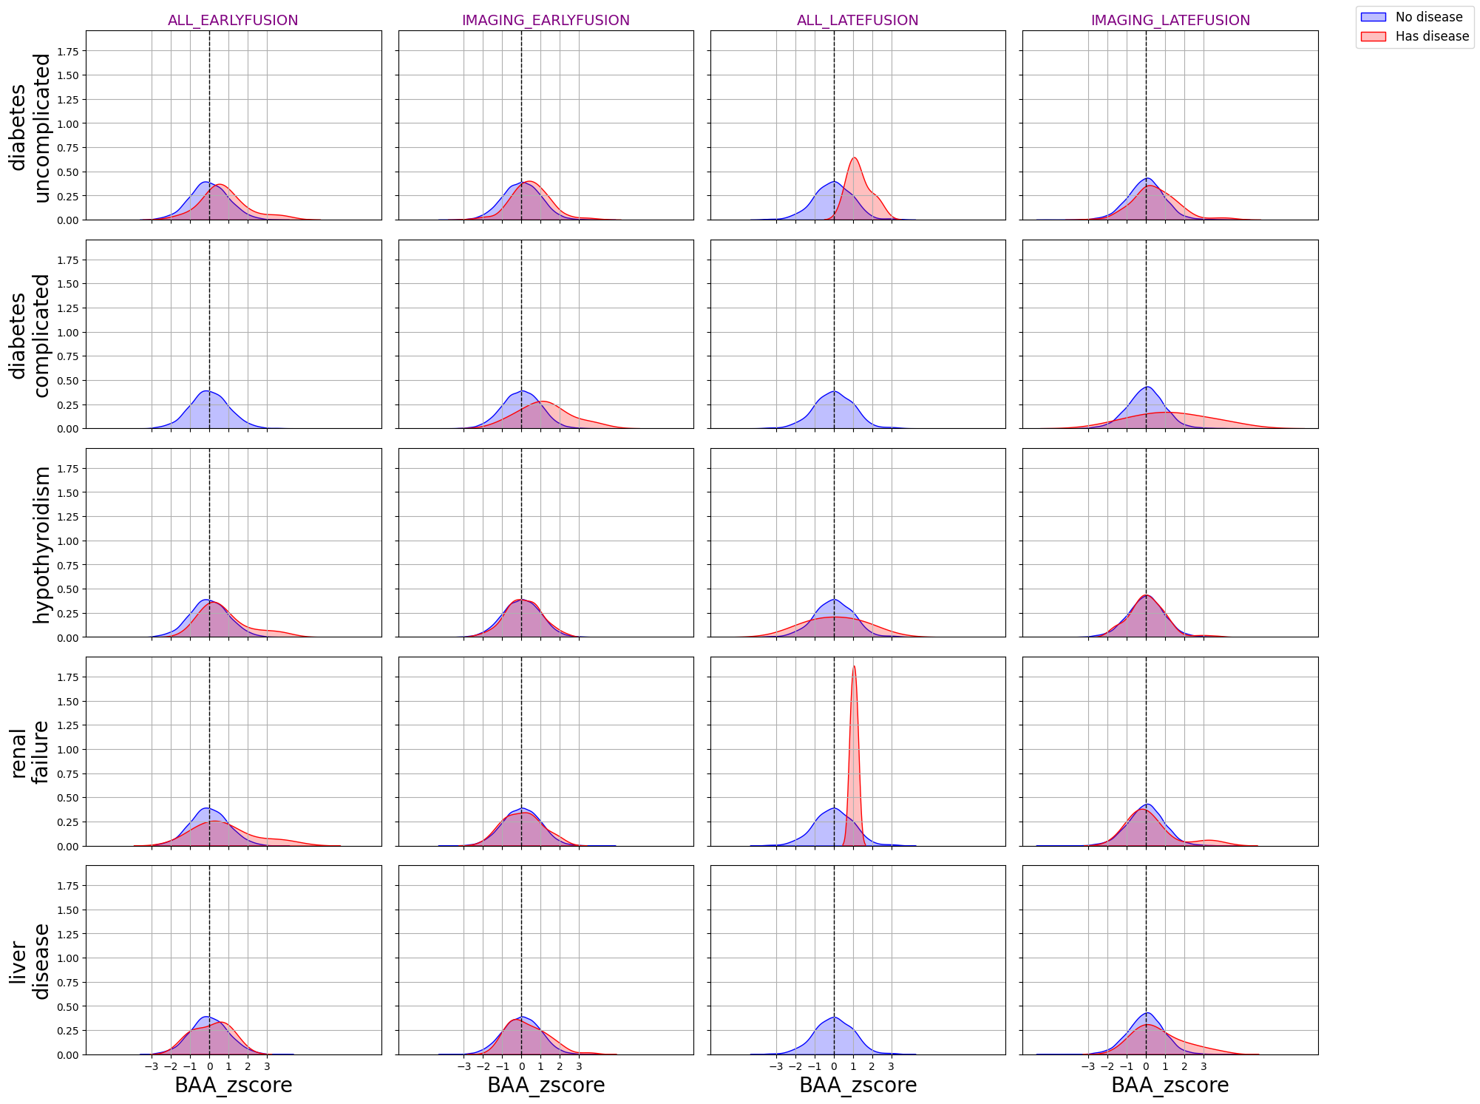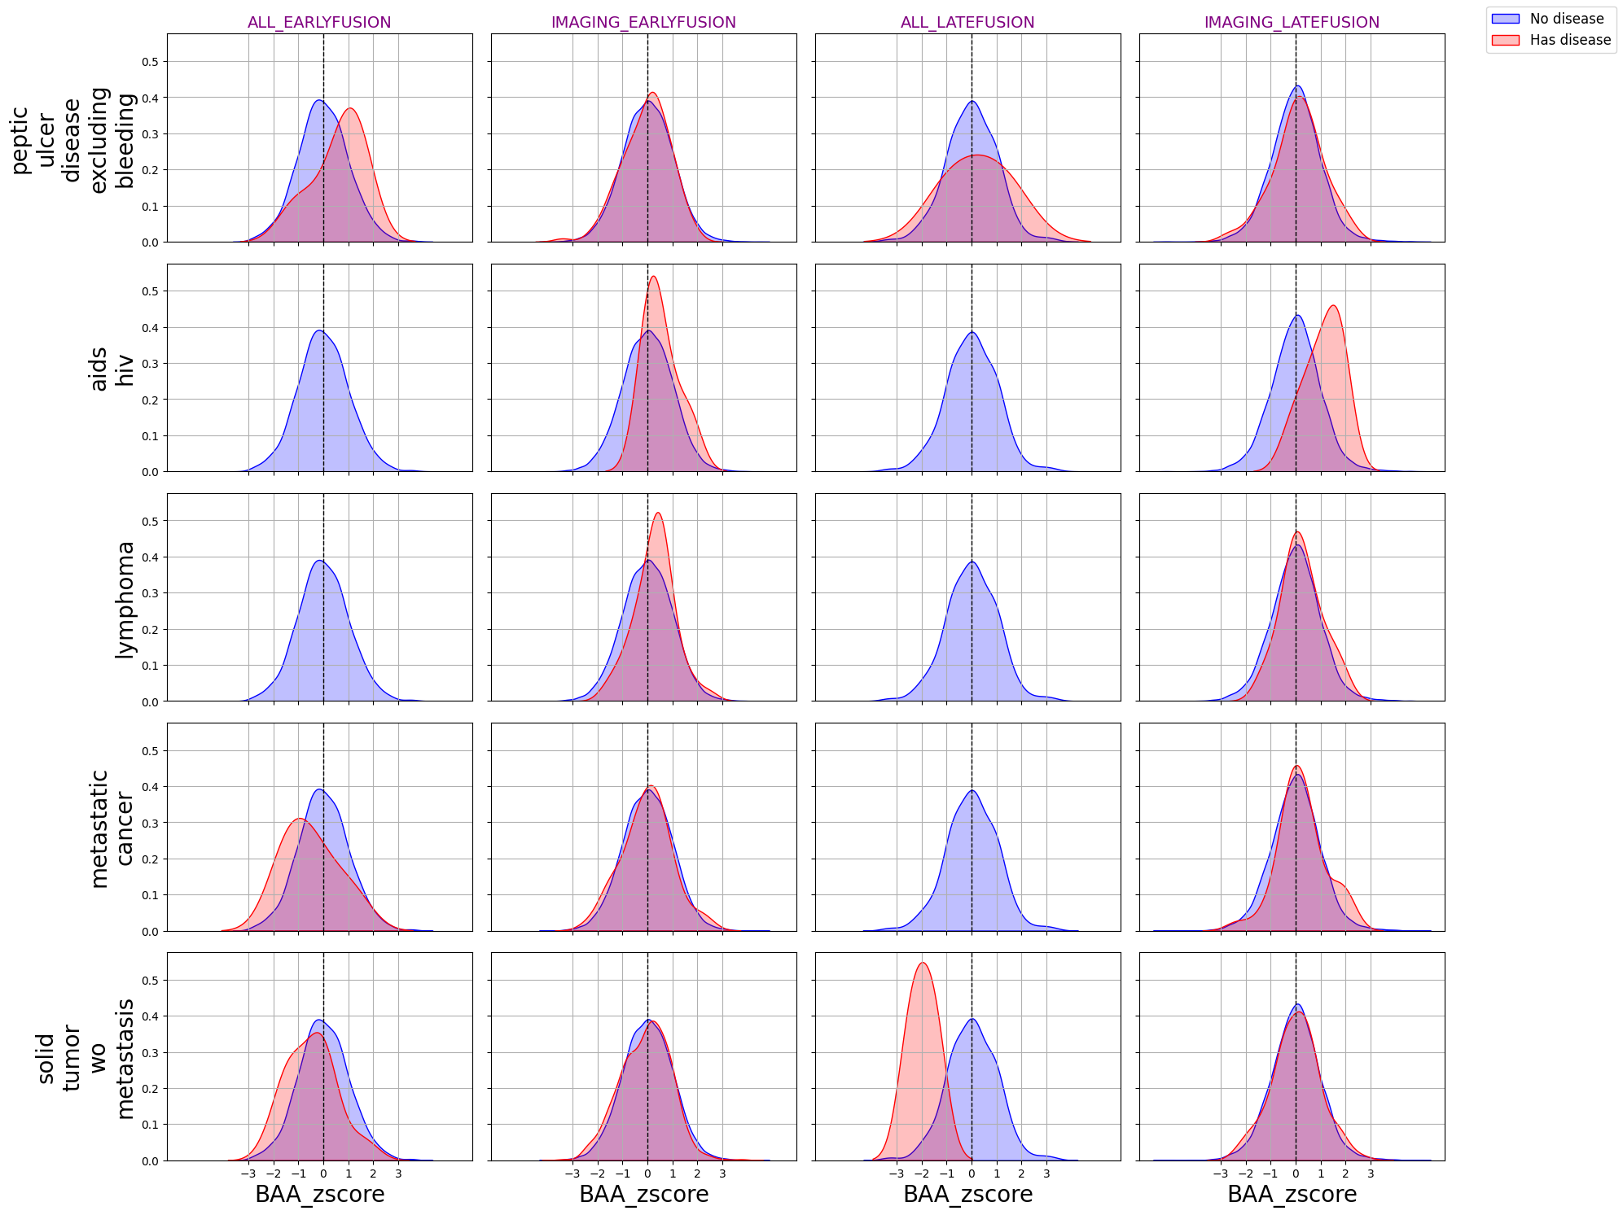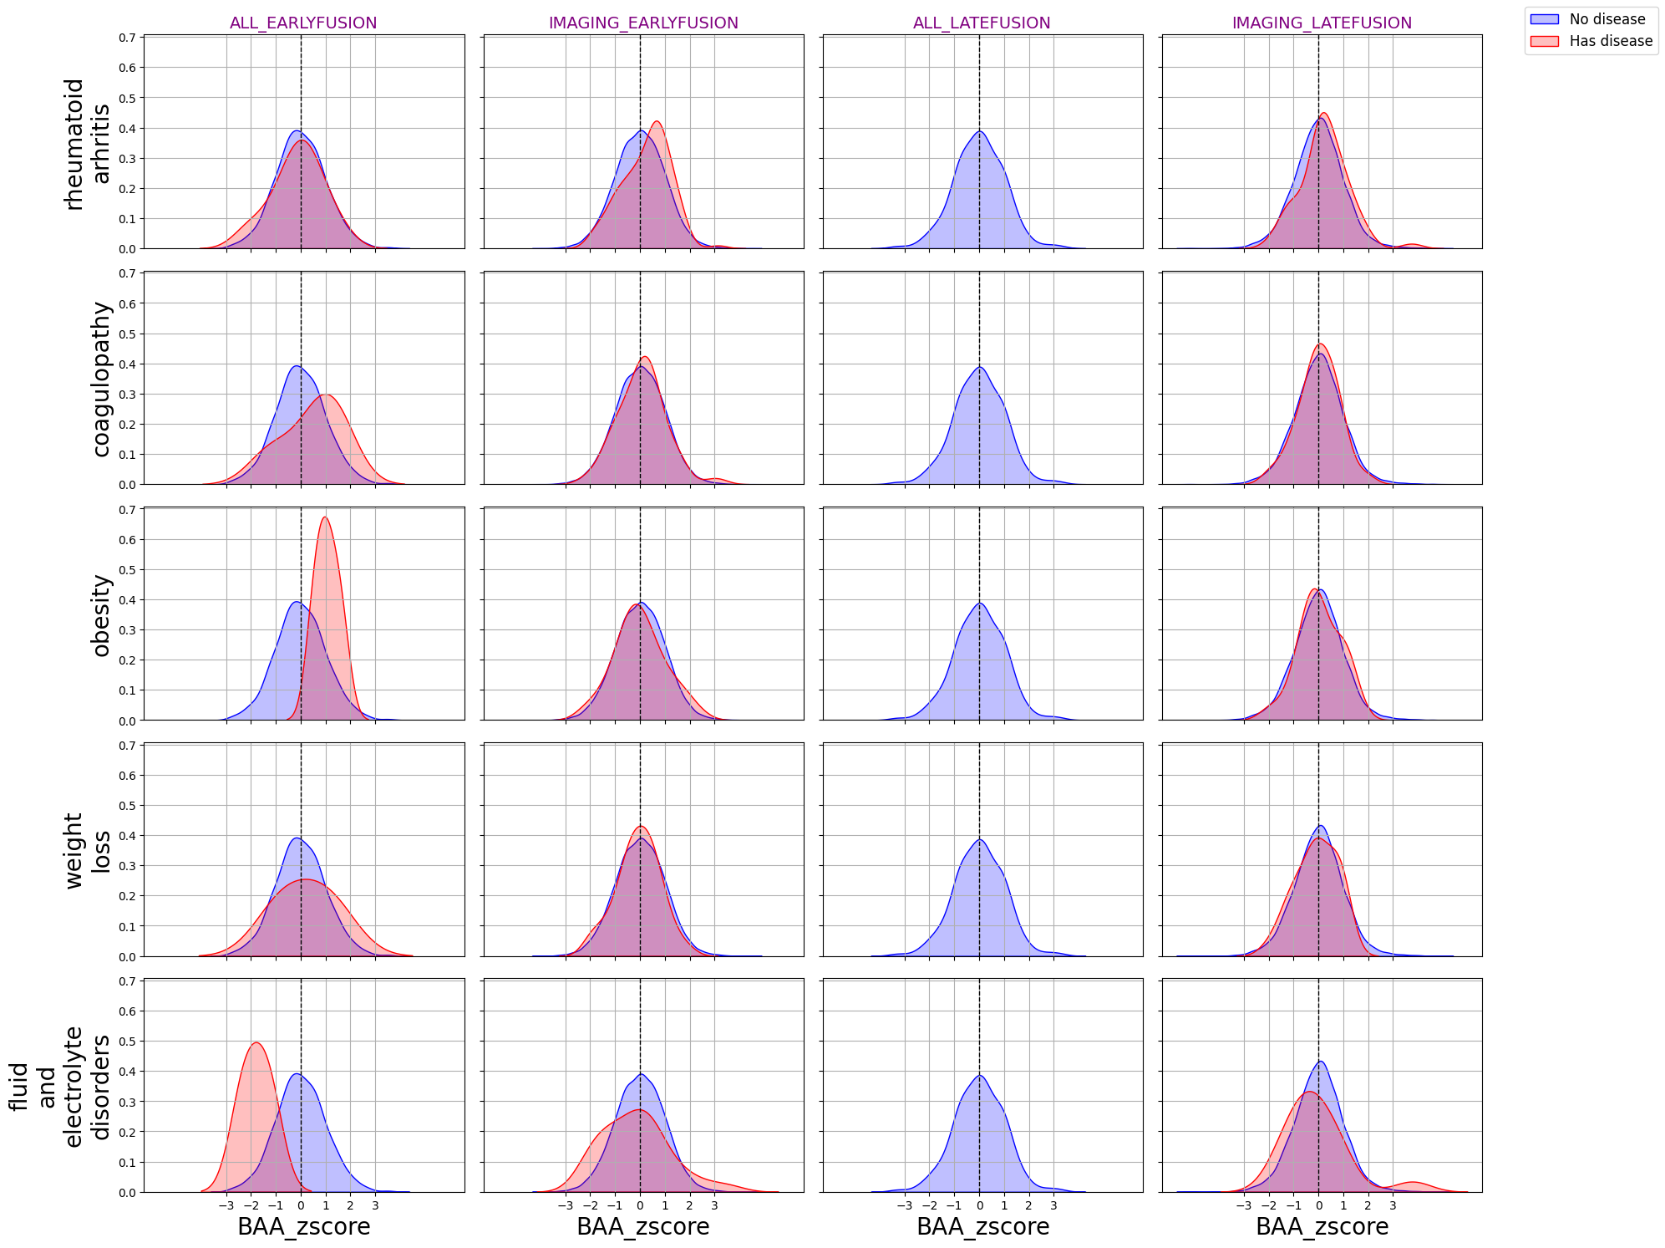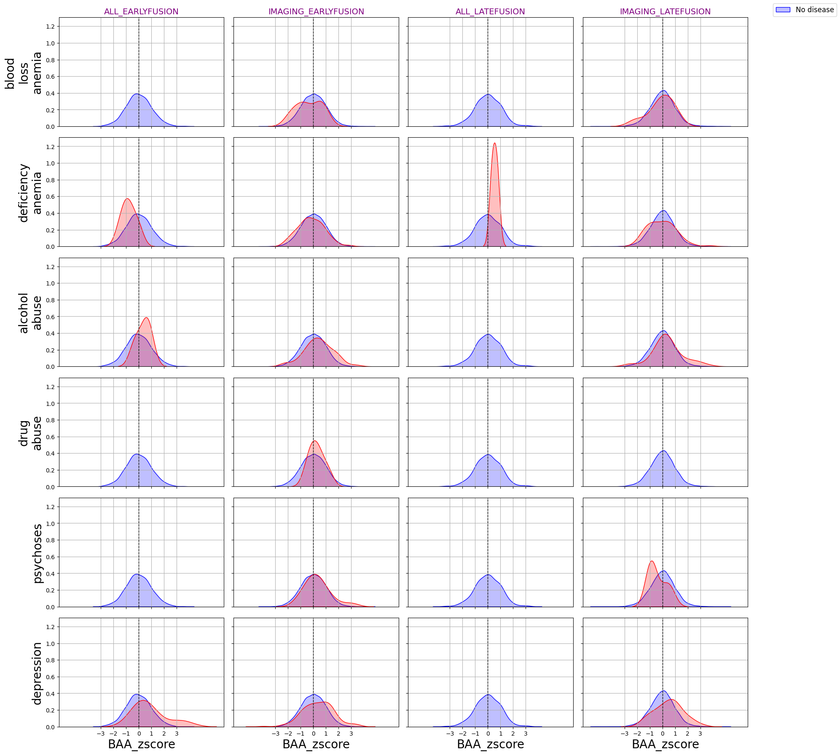

Supplementary Figure 8: distributions of biological age acceleration Z scores for FusionAge-derived aging clocks, in the NHANES cohort; select clocks do not have individuals with that disease and those individuals are not plotted

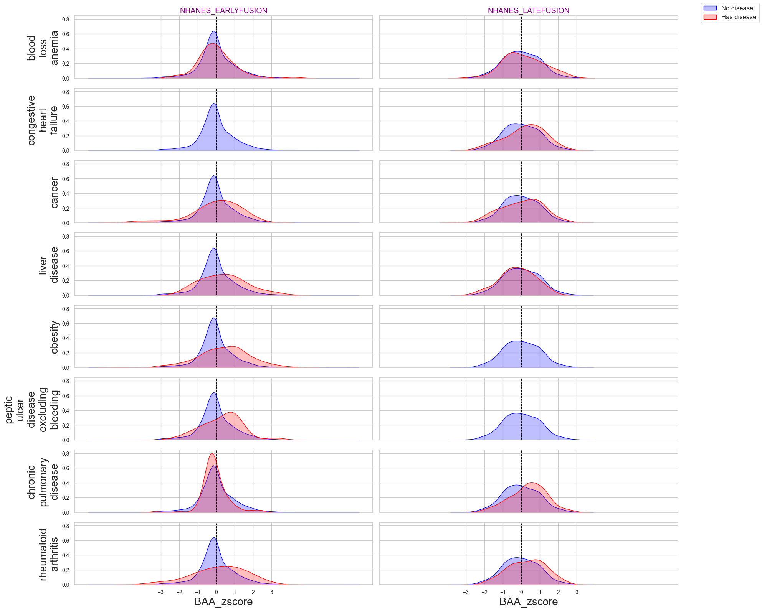

Supplementary Figure 9: proportion of aggregate contribution to biological age, using the top 10 ranked features by individual contribution.
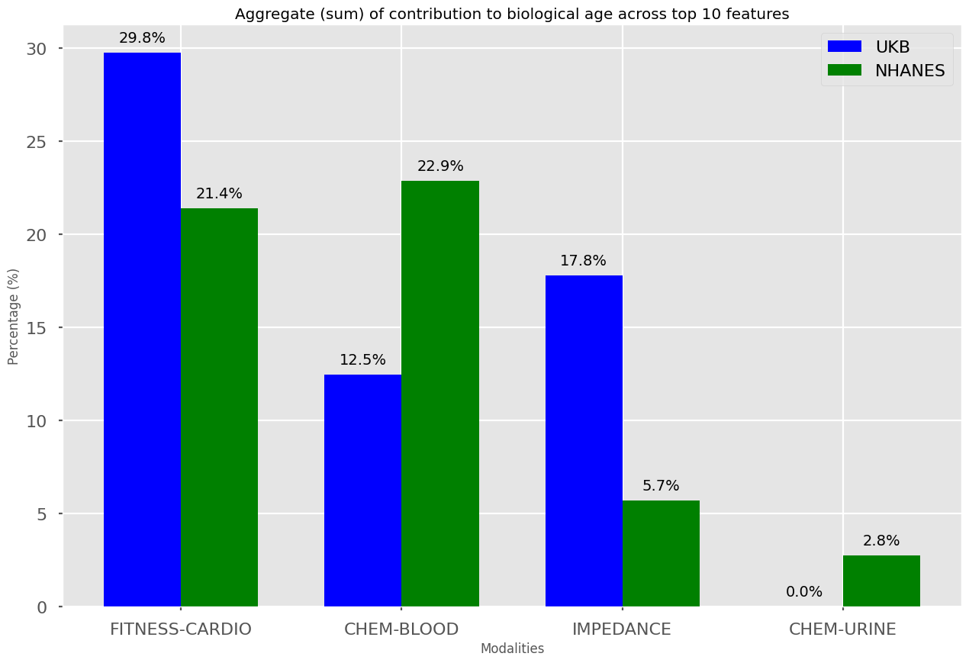

Supplementary Figure 10: residual plots of each clock trained on UK Biobank, multimodal clocks
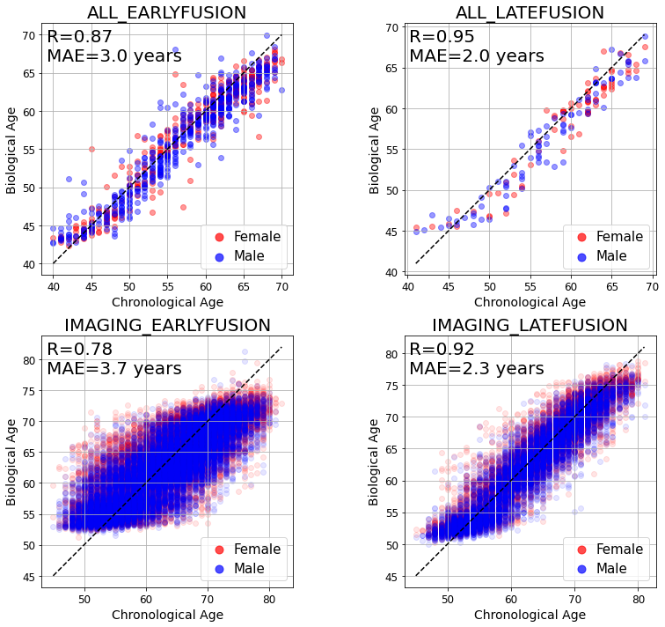

Supplementary Figure 11: residual plots of each clock trained on UK Biobank, modality-specific clocks
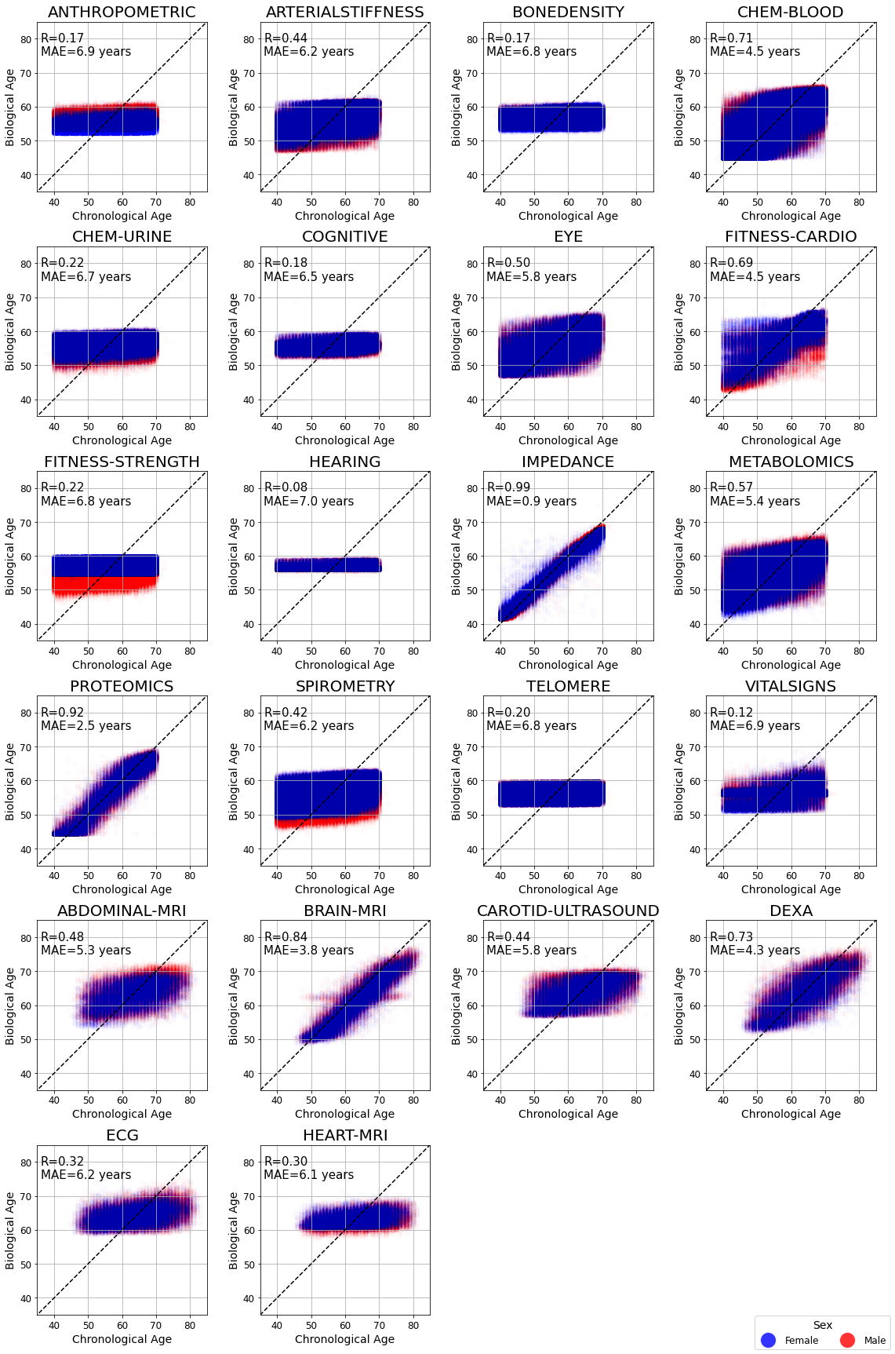

Supplementary Tables - Descriptions

Supplementary table 1 (list of modalities and example features for each), 2 (description of feature construction methods used, across each modality)

Supplementary table 3 (baseline tables for each modality-specific clock (one row per feature, one column per statistic)

Supplementary table 4 (baseline tables for each multimodal clock (one row per feature, one column per statistic)

Supplementary table 5 (performance metrics for all clocks trained on UK Biobank data)

Supplementary table 6 (incident disease associations (AUC in classification) for all clocks trained on UK Biobank data)

Supplementary table 7 (mortality associations (hazard ratio in cox proportional hazard) for all clocks trained on UK Biobank data)

Supplementary table 8 (biological age scores for astronauts)

Supplementary table 9 (baseline tables for each clock from NHANES validation dataset)

Supplementary table 10 (performance metrics for each clock from NHANES validation dataset)

